Clause | Remarks/Guidelines

NTT A11 Formula Approach [optional clause]
(1) Tenders will be evaluated in accordance with the formula approach at Appendix [insert appropriate reference]# to these Notes to Tenderers. Tenderers should note DEVB TC(W) No. 4/2014 and 4/2014A which set out the use of the Formula Approach for tender evaluation. Tenderers shall note that the Government is not bound to accept the tender with the highest overall score or any tender and may cancel the tender exercise on public interest ground. In considering the acceptance of a tender, the Government will take account of all relevant circumstances including the following :-  (i) The overall score;  - The effect of incident of payments by discounting future payments to obtain the present values and use the present values to substitute the forecast total of the Prices in determining the ranking of the tenders, if the forecast total of the Prices/overall scores are very close;  - The effect of exceptionally high or low priced items;  - The tenderer’s capability (financially, commercially and technically) in undertaking this contract. For the avoidance of doubt, matters such as bankruptcy, false declaration, lack of integrity, acts of dishonesty, the latest available information and reports reflecting serious shortfall in performance and the latest available information and reports relating to serious site safety or environmental incidents may be taken into account in determining whether a tenderer is fully capable of undertaking this contract [**. For tenders submitted by EMSTF, the letters of “non-compliance” issued by the relevant regulatory authorities shall also be treated as conviction records];  - The effect of erratic pricing determined in accordance with Clause GCT 14 of the General Conditions of Tender; and  - The interest of national security.  [Set out the details of the Stage I Screening and all the minimum requirements where applicable and the consequences of failing Stage I Screening.] | To be used for tender evaluation using Formula Approach.  Please refer to DEVB TCW No. 4/2014 and 4/2014A. See also SDEV memos ref. DEVB(W) 546/84/01 dated 9.7.2021, DEVB(W) 510/30/01 dated 31.8.2022, DEVB(W) 546/84/01 dated 18.8.2023 and DEVB(W) 546/84/01 dated 10.11.2023.  ** for use in tenders which EMSTF is eligible to bid  # Please insert appropriate reference.  Net present value analysis is NOT applicable for NEC target contracts. Please replace sub-clause (1)(ii) as “not used” for NEC target contracts.

Appendix [X]

The Formula Approach to Tender Evaluation

(1) The Formula Approach to tender evaluation takes into account the forecast total of the Prices and the tenderer’s past performance under public works contracts. With respect to each conforming tender, a combined price and performance (overall) score will be worked out in accordance with the formula below. Normally, the tender with the highest overall score should be recommended for acceptance, subject to the usual requirement that the procuring department is satisfied that the recommended tenderer is fully capable (including technically, commercially and financially) of undertaking this contract, and that the recommended tender is the most advantageous to the Government in accordance with the tender provisions.

60 x | the lowest forecast total of the Prices among those conforming tenders
 | the forecast total of the Prices of the tenderer
+ 40 x | the tenderer’s performance score
 | the highest performance score among those conforming tenders

Forecast total of the Prices is subject to correction rules as stipulated in Clause [insert appropriate reference] of the General Conditions of Tender.

Conforming Tender
(2) For the purpose of calculation using the formula above, a conforming tender means a tender which  (a) conforms to the essential requirements of the tender documentation; *and  (b) is submitted by a tenderer which complies with the conditions of participation*. / *; and  *(c) has passed the Stage I Screening where applicable.  A conforming tender with abnormally low or high tendered total of the Prices or which is considered unsuitable for recommendation for the award of this contract (such as financially, commercially or technically incompetent) remains to be a conforming tender.  Performance Score | * Delete where appropriate.

(3) The “performance score” in the above formula will be worked out in accordance with the formulae below.
For cases where “training rating” is not applicable | Performance score = “performance rating” + “safety rating” + merit/demerit point for safety
For cases where “training rating” is applicable | Performance score = “performance rating” + “safety rating” + “training rating” + merit/demerit point for safety

(4) In case “training rating” is applicable, the full mark of the “performance score” will be increased from 111 (i.e. 100 for “performance rating”, 10 for “safety rating” and 1 for merit/demerit point for safety) to 112 or 113 (with an addition of 1 or 2 mark for “training rating”).

(A) Performance rating

(5) The “performance rating” means the performance rating held in the DEVB’s Contractors’ Performance Index System (CMIS) on the original date set for the return of tenders or, if this has been extended, the extended date. The maximum rating in the CMIS is 100.

(6) If a tenderer has been enlisted by way of substitution, the performance rating of this tenderer as recorded in the CMIS will take into account the past performance of the previous contractor.

(7) If a tenderer does not have a rating on the particular date, it shall be assigned an average performance rating based on the performance ratings of the other tenderers who have submitted a conforming tender. In cases where the only conforming tenderer does not / all the conforming tenderers do not have any performance rating on the particular date, the tenderer(s) concerned will be given a performance rating of 50% of the maximum rating.

Joint venture

(8) The “performance rating” of a joint venture tenderer shall be evaluated as the higher of either –

(i) the weighted average of the performance ratings of the participants or shareholders in the joint venture in accordance with their percentage participation; or

(ii) the performance rating attained by the lead participant or major shareholder in the joint venture provided that the lead participant or major shareholder has a percentage participation of at least 70%; and that-

(I) all the other participants or shareholders are in the same Category as the lead participant or major shareholder and on the confirmed or probationary status of the same Group as the lead participant or major shareholder (where the lead participant or major shareholder is a confirmed contractor); or

(II) all the other participants or shareholders are in the same Category as the lead participant or major shareholder and on probationary status of the same Group or on confirmed status of a Group lower than that of lead participant or major shareholder (where the lead participant or major shareholder is a probationary contractor).

Where contractors not on the List of Approved Contractors for Public Works or contractors of more than one Category are invited to tender, only the method in (i) above is applicable in evaluation of performance rating of a joint venture tenderer.

(9) For the purpose of evaluation using the method in paragraph 8(i) above, if a participant/shareholder in a joint venture has no performance rating, it will not be given any performance rating and its percentage participation shall be excluded from the calculation of the performance rating of the joint venture tenderer under paragraph 8(i). For example, if joint venture tenderer A is composed of 3 participants X, Y and Z with 30%, 30% and 40% shares respectively. If participant X has a performance rating of 60, participant Y has a performance rating of 50 and participant Z has no performance rating, the performance rating for the joint venture tenderer A shall be (60 x 0.3 + 50 x 0.3)/(0.3 + 0.3) = 55. If none of the participants/shareholders in this joint venture has any performance rating, the performance rating of this joint venture tenderer shall be calculated in accordance with paragraph 7 above by considering this joint venture tenderer being a tenderer as described in that paragraph.

(B) Safety rating

Calculation of safety rating

(10) The “safety rating” is worked out from the past accident rates under public works contracts as per the accident and records of man-hours worked kept in DEVB’s PWP Construction Site Safety & Environmental Statistics (PCSES) for three 12-month periods fixed by reference to the original date set for the close of tender or, if this has been extended, the extended date, according to paragraphs 11 to 16 below.

(11) The three 12-month periods shall end on the last day of the calendar month immediately preceding the dates being 2 months (1st 12-month period), 14 months (2nd 12-month period) and 26 months (3rd 12-month period) respectively counting back from but excluding the original date set for the close of tender or, if this has been extended, the extended date. A table showing the three 12-month periods and measuring dates for tender closing dates is given below for illustration purpose.

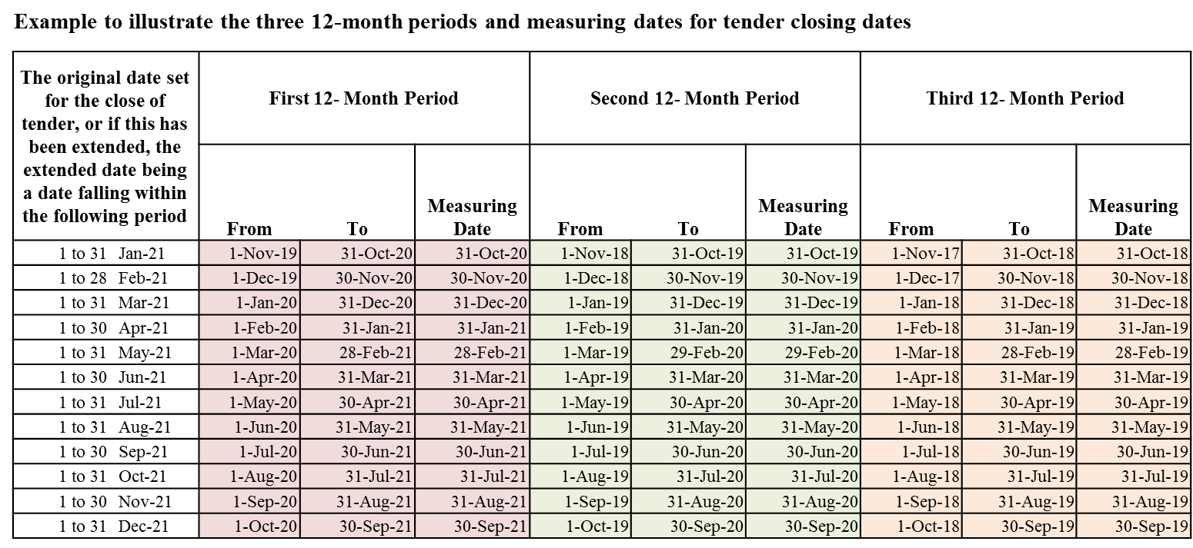

(12) The following formula shall be used for calculating the accident rates for the concerned 12-month periods: -

Accident Rate = | (No. of non-fatal reportable accidents ^{Note 1} in the period) | + | (No. of fatal accidents in the period)
 | Total no. of man-hours worked in the period/100,000 man-hours

^{Note 1} Reportable accidents mean those accidents resulting in an injury with incapacity for more than three days and all fatal accidents.

(13) For “safety rating”, the maximum total is 10 for the total of the three 12-month periods. The first, second and third 12-month periods have a maximum rating of 5, 3 and 2 respectively. Each tenderer’s safety rating is worked out by reference to the table below and shall be the sum of the three ratings corresponding to the three 12-month periods.
Tenderer’s Accident Rate@ | Rating
 | 1st  12-month | 2nd  12-month | 3rd  12-month
accident rate ≤ 25% of the limit # | 5 | 3 | 2
25% of the limit < accident rate ≤ 50% of the limit | 3.75 | 2.25 | 1.5
50% of the limit < accident rate ≤ 75% of the limit | 2.5 | 1.5 | 1
75% of the limit < accident rate ≤ 100% of the limit | 1.25 | 0.75 | 0.5
accident rate > 100% of the limit | 0 | 0 | 0

@ The unit of accident rate is number of accident per 100,000 man-hours worked.

# The limit of accident rate currently set by DEVB is 0.6.

(14) If a tenderer does not have an accident rate for a particular 12-month period (on the ground of no man-hour worked for that period), the accident rate to be used for that period shall be the average of accident rates for the other two periods. If a tenderer has an accident rate for one of the three 12-month periods only, that accident rate shall be used for calculating the safety rating for the other two 12-month periods.

(15) For a tenderer without any accident rate for the past three 12-month periods, its safety rating shall be the average safety rating attained by the other tenderers with a safety rating who have submitted a conforming tender.

(16) In cases where the only conforming tenderer does not/all the conforming tenderers do not have any accident rate for the past three 12-month periods, the tenderer(s) concerned will be given a safety rating of 50% of the maximum rating.

Joint venture

(17) The safety rating of a joint venture tenderer shall be the weighted average (in accordance with their percentage participation) of the safety ratings of the individual participants or shareholders which shall each be calculated in accordance with paragraphs 11 to 14 above.

(18) If a participant/shareholder in a joint venture does not have an accident rate for the past three 12-month periods, it will not be given any safety rating and its percentage participation shall be excluded from the calculation of the safety rating of the joint venture tenderer under paragraph 17.

(19) If none of the participants/shareholders in a joint venture has any accident rate for the past three 12-month periods, the safety rating of this joint venture tenderer shall be calculated in accordance with paragraphs 15 - 16 above by considering this joint venture tenderer being a tenderer as described in those paragraphs.

(20) In calculating the accident rates of each participant/shareholder of a past/existing joint venture contract, the accident rates of the whole joint venture contract shall be used and attributed to the participant/shareholder irrespective of its share of the work in the past/existing joint venture contract.

Accident rates for tenders with or without involvement of Contractors of the Buildings Category
(21) For tenders invited from contractors of the Buildings category, the accident rates for completed and on-going contracts in the Buildings category only will be used in the calculation of the accident rates, hence the safety ratings for the assessment of tenders. For tenders invited from contractors from any category/categories other than the Buildings category, the accident rates for completed and on-going contracts in non-Buildings categories (i.e. all other categories) will be used. For tenders invited from contractors in more than one category including the Buildings category, the accident rates for all completed and on-going contracts in all categories will be used.  (C) Training rating** | For open tendering, departments should decide whether the accidents rates for all completed and on-going contracts in Buildings category, non-Buildings categories or all categories will be used.
(22) The full mark for training rating shall be [X]##.  (23) The “training rating” of a tenderer is worked out based on its past records of training workers to skilled/semi-skilled levels in public works contracts via joining the collaborative training schemes (including Contractor Collaborative Training Scheme (CCTS), Intermediate Tradesman Collaborative Training Scheme (ITCTS) (formerly called Construction Tradesman Collaborative Training Scheme (CTS)), Advanced Construction Manpower Training Scheme (ACMTS) and Construction Industry Council Approved Technical Talents Training Programme (CICATP) administered by the Construction Industry Council (CIC) in the stated period, and its manpower deployment in public works contracts in the same period. | ** The “training rating” shall be incorporated in the Formula Approach as well as the Standard Marking Scheme for evaluating tenders invited from Group C contractors. In the case of open tendering, or where tenders are invited from contractors other than Group C contractors enlisted in any category of the List of Approved Contractors for Public Works, the “training rating” shall also be incorporated in the Formula Approach and the Standard Marking Scheme for evaluating tenders if the department has assessed that not less than 80% of potential tenderers would be Group C contractors enlisted in any category of the List of Approved Contractors for Public Works so that the past performance assessment criterion in connection with the provision of on-the-job training to workers could be meaningfully adopted and put to use.
(24) The “training rating” shall be calculated using the below formula –  Training rating (Max = full mark) = full mark x Training score in the stated period  Total “man-year” worked in the stated period / 20  (25) For a tenderer who (i) does not have any total “man-year” worked in the stated period; or (ii) has total “man-year” worked below 20 and a training score of “0” in the stated period; or (iii) is not a Group C contractor ^{Note 2} in the stated period, its training rating shall be the average training rating attained by other tenderers with a training rating who have submitted a conforming tender.  ^{Note 2} In the context of training rating, a Group C contractor means a Group C contractor enlisted in any category of the List of Approved Contractors for Public Works.  (26) In cases where the only conforming tenderer/each of all the conforming tenderers (i) does not have any total “man-year” worked in the stated period; or (ii) has total “man-year” worked below 20 and a training score of “0” in the stated period; or (iii) is not a Group C contractor in the stated period, the tenderer(s) concerned will be given a training rating of 50% of the full mark.  Training score | [X]##, i.e. the full mark, shall be determined as follows:-  Estimated Forecast Total of the Prices Value of X  > $1 billion 1  ≤ $1 billion 2

(27) The training score of a tenderer should be worked out using the number of workers trained as detailed below –

1 training score for each of his CCTS or ITCTS trainees in public works contracts who: (a) is registered as the registered semi-skilled worker of the trained trade under the Construction Workers Registration Ordinance (Cap. 583) (CWRO); or (b) has passed the end-of-training assessment under CCTS or ITCTS if such trade has no corresponding trade division under CWRO, or if CWRO does not allow registration of registered semi-skilled worker for the corresponding trade division, during the stated period;

2 training scores for each of his ACMTS or CICATP trainees in public works contracts who has passed CIC’s mid-term assessment of ACMTS or CICATP for the trained trade during the stated period;

2 training scores for each of his ACMTS or CICATP trainees in public works contracts who is registered as the registered skilled worker of the trained trade under CWRO during the stated period; and

0 training score if none of the above applies.

(28) To cope with the characteristics of the construction industry that most of the skilled workers are employed by sub-contractors, CCTS, ITCTS, ACMTS or CICATP trainees employed and trained by sub-contractors in a public works contract will be counted as the trainees under the main contractor for the purpose of calculating the training rating. A trainee will be counted as receiving training under a public works contract so long as such contract is stated, in the trainee’s application form for joining the collaborative training schemes, as the public works contract under which the trainee will mainly receive training. Such information will be duly reflected in CIC’s Collaborative Training Schemes Statistics System (CTSSS).

(29) The tenderers’ training records under CCTS, ITCTS, ACMTS and CICATP to be used for calculating “training rating” are kept in CIC’s CTSSS accessible via CIC’s website at http://www.cic.hk/ctsss. The training score of a tenderer should be worked out based on paragraph 27 above, using the number of workers trained by the tenderer as recorded in the CTSSS.

Total “man-year” worked

(30) The total “man-year” worked of a tenderer shall be equal to the total “man-day” worked for all public works contracts of the tenderer in the stated period kept in the PCSES, divided by 295 work days per year.

Stated period

(31) The stated period shall be 36 months ending on the last day of the calendar month immediately preceding the dates being 2 months counting back from but excluding the original date set for the close of tender, or if this has been extended, the extended date.

(32) For tenderer who is not a Group C contractor of any category immediately preceding the start date of the stated period, the stated period for such tenderer shall start on the first date of the calendar month immediately following the earliest date on which the tenderer becomes a Group C contractor. An example is provided below for illustration purpose.

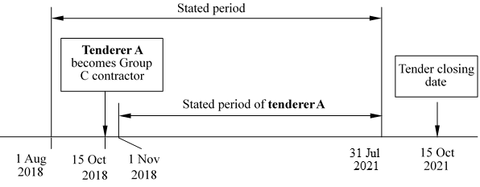

(33) The following examples are provided to illustrate the calculation of training rating.

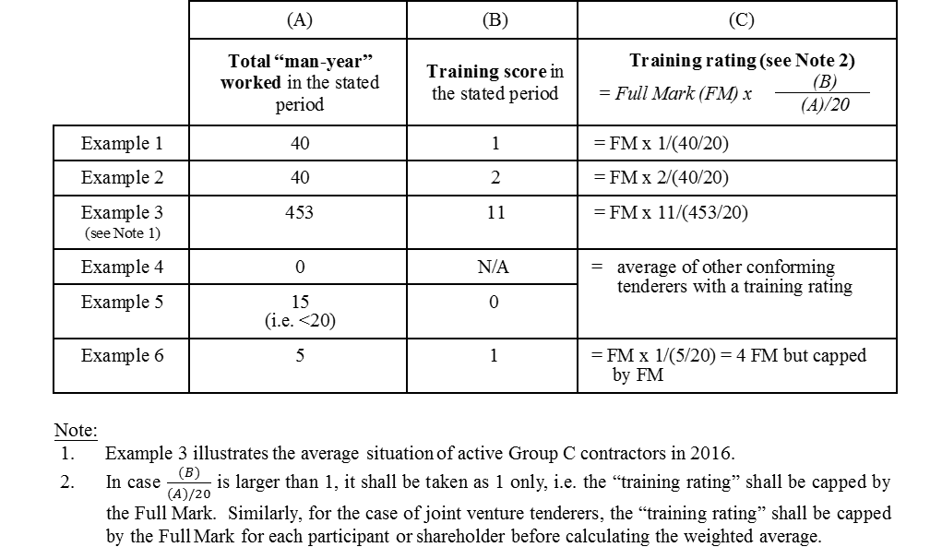
Joint venture

(34) For joint venture tenderers -

A “specified participant/shareholder” in a joint venture means a participant/shareholder who -

does not have any total “man-year” worked in the stated period;

has total “man-year” worked below 20 and a training score of “0” in the stated period; or

is not a Group C contractor in the stated period.

Subject to paragraphs (iii) and (iv) below, the training rating of a joint venture tenderer shall be the weighted average (in accordance with their percentage participation) of the training ratings of its participants or shareholders which shall each be calculated in accordance with paragraphs 23 to 33 (excluding 25 & 26) above.

If a participant(s)/shareholder(s) in a joint venture is a specified participant/shareholder

, it will not be given any training rating and its percentage participation shall be excluded from the calculation of the training rating of the joint venture tenderer under paragraph (ii) above.

If all the participants/shareholders in a joint venture are specified participants/shareholders, the training rating of this joint venture tender shall be calculated in accordance with paragraphs 25-26 above by considering this joint venture tenderer being a tenderer as described in those paragraphs.

(35) The following table illustrates the calculation of the training rating for joint venture tenderer.

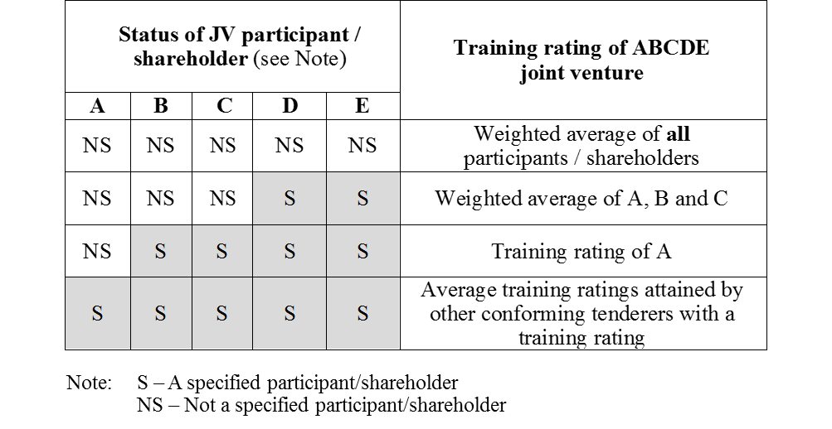

(36) In calculating the training rating of each participant/shareholder of a past/existing joint venture contract, the training rating of the whole joint venture contract shall be used and attributed to the participant/shareholder irrespective of its share of the work in the past/existing joint venture contract.

Merit / Demerit Point for Safety

(37) The “merit/demerit point for safety” is dependent on (i) whether a tenderer has or may have caused or contributed (whether by act or omission) to any incident involving loss of life or incident involving serious bodily injury ^{Note 1} at a construction site ^{Note 2} in Hong Kong (hereinafter collectively referred to as “Serious Incident”) during the Relevant Period as defined in paragraph 39 below; and (ii) whether such tenderer held any on-going works contract during the Relevant Period.

^{Note 1} “Serious bodily injury” shall bear the same meaning as assigned to it under paragraph 10(g)(ii) of DEVB TC(W) No. 5/2023 dated 28 July 2023 or any subsequent update.

^{Note 2} “Construction site” shall bear the same meaning as defined in paragraph 10(a) of DEVB TC(W) No. 5/2023 dated 28 July 2023 or any subsequent update.

(38) The merit/demerit point for safety applicable to a tenderer under different situations is as follows:

Situation | The tenderer has or may have caused or contributed to a Serious Incident during the Relevant Period | The tenderer held an on-going works contract during the Relevant Period | Merit / Demerit Point for Safety (mark)
I | No | Yes | +1
II | No | No | ^{Note 3}
III | Yes (not involving any loss of life) | Yes or No | -0.5
IV | Yes (involving loss of life) [^{Note 4}] | Yes or No | -1

^{Note 3} Merit / Demerit Point for Safety for a tenderer falling within Situation II shall be the average mark obtained by all conforming tenderer(s), excluding those who fall within Situation II.

Provided that if the only conforming tenderer falls / all conforming tenderers fall within Situation II, +0.5 mark will be given to it/them. For the avoidance of doubt, a participant or shareholder of a joint venture tenderer is not regarded as a conforming tenderer.

^{Note 4} For the avoidance of doubt, if a tenderer has or may have caused or contributed to a Serious Incident involving any loss of life, it will be considered as falling within Situation IV, regardless whether the tenderer has or have caused or contributed to any other Serious Incident not involving any loss of life.

(39) For the purpose of assessing the merit/demerit point for safety:  - Relevant Period means the period between and inclusive of the two dates below:-  - the first day of the 14th calendar month immediately preceding the calendar month in which the original date set for close of tender is in or, if this has been extended, the extended date; and  - the last day of the 3rd calendar month immediately preceding the calendar month in which the original date set for close of tender is in or, if this has been extended, the extended date.  - A tenderer is regarded as having or may be having caused or contributed to a Serious Incident during the Relevant Period if:  - According to the information provided by Labour Department or other relevant government departments as described in paragraph 13 of DEVB TC(W) No. 5/2023 dated 28 July 2023 or any subsequent update, the tenderer was involved in a Serious Incident occurred during the Relevant Period; and  - On the basis of the aforesaid information, DEVB consider that the tenderer has or may have caused or contributed to the Serious Incident in any capacity whatsoever, including but not limited to main contractor and subcontractor at any tier^.  - A tenderer is regarded as holding an on-going works contract during the Relevant Period if:-  - The tenderer is acting in the capacity of the main contractor or is a participant/shareholder of a joint venture acting in the capacity of a main contractor of a public or private works contract at any point of time during the Relevant Period;  - The whole or part of the works under the said contract is to be or has been carried out in a construction site ^{See Note 2 above} in Hong Kong; and  - The said contract has commenced on or before the last day of the Relevant Period and the works under the said contract as a whole (excluding Maintenance Period) have not been certified complete by the Engineer / Architect / Surveyor / Supervising Officer/ Authorised Person or other equivalent professionals before the Relevant Period commences or, in the case of term contract, the contract term has not yet expired before the Relevant Period commences. | ^ The procuring departments shall refer to the records kept in DEVB’s Works Group Intranet Portal.

(40) A tenderer should provide sufficient documentary evidence of any on-going works contract held by it (e.g. articles of agreement, recent correspondences issued by the Engineer / Architect / Surveyor / Supervising Officer / Authorised Person and the like for the contract). If a tenderer fails to demonstrate that it has one or more on-going works contract, its tender shall be assessed as if it held no on-going works contract during the Relevant Period.

Joint venture

(41) The merit/demerit point for safety for a joint venture tenderer shall, subject to paragraphs 42 and 43 below, be the weighted average (in accordance with their percentage participation) of the merit/demerit point for safety of its participants or shareholders which shall each be calculated in accordance with paragraphs 37 to 39 above.

(42) If a participant/shareholder in a joint venture falls within Situation II in the table under paragraph 38, it will not be given any merit/demerit point for safety and its percentage participation shall be excluded from the calculation of the merit/demerit point for safety of the joint venture tenderer under paragraph 41.

(43) If all participants/shareholders in a joint venture fall within Situation II in the table under paragraph 38, the merit/demerit point for safety of the joint venture tenderer shall be calculated as if it is a tenderer falling within Situation II in the said table.

Obtain present value by discounting future payments
(44) For tenders with a forecast total of the Prices, if the tendered sums or the overall scores of the tenders under consideration with highest overall scores are very close (usually the three with the highest overall score), the procuring department should consider discounting future payments to obtain the present value and use the present value instead of the forecast total of the Prices in determining the ranking of the tenders. This calculation exercise should only apply to those conforming tenders with the highest overall scores (usually the top three). | Net present value analysis is NOT applicable for NEC target contracts. Please replace paragraph (44) as “not used” for NEC target contracts.

